INTRODUCTION TO DATA MANAGEMENT
PROJECT REPORT
(Project Semester January-April 2025)

Real Estate Sales Dashboard

Submitted by
Aditya Raj
Registration No:
12303390

Programme and Section:
Bachelor of Technology (CSE) – KM005
Course Code:
INT217

Under the Guidance of

Baljinder Kaur (27952) Assistant Professor

Discipline of CSE/IT

Lovely School of Computer Science and Engineering

Lovely Professional University, Phagwara

CERTIFICATE

This is to certify that Aditya Raj bearing Registration Number 12303390 has completed INT217 project titled, “Real Estate Sales Dashboard” under my guidance and supervision. To the best of my knowledge, the present work is the result of his/her original development, effort and study.

Baljinder Kaur
Assistant Professor
School of Computer Science and Engineering
Lovely Professional University
Phagwara, Punjab.

Date:

DECLARATION

I, Aditya Raj, student of Bachelor of Technology under CSE/IT Discipline at, Lovely Professional University, Punjab, hereby declare that all the information furnished in this project report is based on my own intensive work and is genuine.

Date: Signature
Registration No. 12303390 Aditya Raj

ACKNOWLEDGEMENT
I would like to express my sincere gratitude to all those who supported me throughout the completion of this project titled
“Real Estate Sales Dashboard”
First and foremost, I would like to thank Baljinder Kaur, my respected project supervisor, for her invaluable guidance, support, and encouragement. Her expert advice, timely feedback, and motivation helped me stay focused and complete this project efficiently.
I would also like to extend my appreciation to the faculty and staff of the Discipline of CSE/IT, Lovely Professional University, for creating a learning environment that inspired this research.
A special thanks to my peers, friends, and family for their constant moral support and encouragement throughout the project.
Lastly, I would like to acknowledge the use of the dataset provided by Data.gov which served as the foundation for the analysis conducted in this report.
Aditya Raj
Registration No.: 12303390

Table of Contents
S. No. | Content | Page No.
1 | Introduction | 6
2 | Source of Dataset | 6
3 | Dataset Preprocessing | 6
4 | Analysis on Dataset | 7
 | 4.1 Objective 1: To analyze and track total sales and average sale price over the years, helping stakeholders identify sales trends, growth patterns, and pricing strategies. | 7
 | 4.2 Objective 2: To measure and analyze the variance between the assessed value and the actual sale price, helping stakeholders identify pricing trends, valuation accuracy, and potential under- or over-valuations. | 8
 | 4.3 Objective 3: To rank cities based on total sales and identify the top five cities contributing the most revenue, helping in strategic decision-making for market focus and resource allocation. | 9
 | 4.4 Objective 4: To calculate and analyze the total revenue generated for each property type, providing insights into which property categories contribute the most to overall sales. | 10
 | 4.5 Objective 5: To analyze how accurately properties are assessed over time and across different property types, identifying patterns of over- or under-valuation that can help improve valuation models. | 11
 | 4.6 Objective 6: Enable Dynamic Filtering with Slicers | 12
5 | Conclusion | 13
6 | Future Scope | 14
7 | References | 14
8 | Social Media Engagement | 14

- Introduction
The real estate industry plays a pivotal role in a country's economy by affecting GDP, employment, and investment flows. Understanding trends in sales, property types, and city-wise performance helps stakeholders—buyers, sellers, developers, and policymakers—make data-informed decisions. This report presents a comprehensive analysis of real estate transactions in Connecticut (U.S.A.), leveraging historical sales data from 2006 to 2022.
The report explores:
- Market trends over time
- Pricing strategies and value assessments
- Geographical hotspots for real estate investment
- Popular property types contributing to revenue
All insights are supported with charts and pivot tables constructed in Microsoft Excel.

- Source of Dataset
The dataset used is from the official U.S. Government’s Open Data platform:
- Source URL: https://catalog.data.gov/dataset/real-estate-sales-2001-2018
It includes property sale records across multiple towns, types, and years, giving us a reliable view of the real estate landscape.

- Dataset Preprocessing
Before performing analysis, the dataset was cleaned and transformed to ensure consistency:
- Missing Values: Removed or imputed null sale amounts and assessed values.
- Date Formatting: Standardized all records to extract the sale year.
- Currency Conversion: Converted values to billions of USD for readability.
- Filtering: Retained records from 2006 to 2022 to focus on recent trends.
- Categorization: Grouped property types into simplified categories (Single Family, Condo, Residential, Vacant Land, etc.).
The resulting clean dataset enabled accurate and relevant analysis through pivot tables and graphs.

- Analysis on Dataset (Objective-wise)

Objective 1: To analyze and track total sales and average sale price over the years, helping stakeholders identify sales trends, growth patterns, and pricing strategies.

- General Description
This objective focuses on understanding how total sales and the number of properties sold have evolved year by year. It helps to identify growth patterns, economic impacts, and pricing trends in the real estate market.
- Specific Requirements
- Calculate the sum of sales per year.
- Track the number of properties sold annually.
- Identify peaks, dips, and any irregular trends.
- Analysis Results
- Highest sales occurred in 2020 with $29.11B from 60,728 properties.
- The lowest was in 2022, with $5.66B from just 10,546 properties.
- A consistent rise in sales is noted from 2016 to 2020, followed by a sharp drop in 2021 and 2022.
- Total sales amount across all years is $241.63B with 655,011 properties sold.
- Visualization
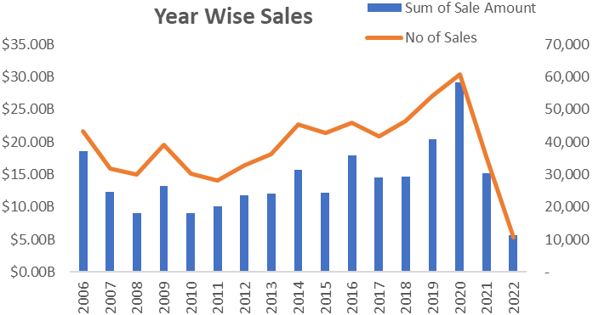
Figure 1
- Shown in the “Year Wise Sales” chart with dual axes:
  - Bar chart for Sum of Sale Amount
  - Line chart for Number of Sales

Objective 2: To measure and analyze the variance between the assessed value and the actual sale price, helping stakeholders identify pricing trends, valuation accuracy, and potential under- or over-valuations.
    - General Description
This objective helps determine how accurate property valuations are compared to actual sale prices. It indicates market volatility and helps improve property assessment methods.
    - Specific Requirements
- Calculate yearly totals for both assessed value and sale amount.
- Compare and identify the variance.
- Observe years with large differences to flag over/under-valuations.
    - Analysis Results
- In all years, sale amount > assessed value, indicating frequent under-assessment.
- 2020 shows the highest variance, with $29.11B in sales vs. $17.58B in assessed value.
- Total assessed value = $165.05B, significantly lower than the total sales value of $241.63B.
    - Visualization
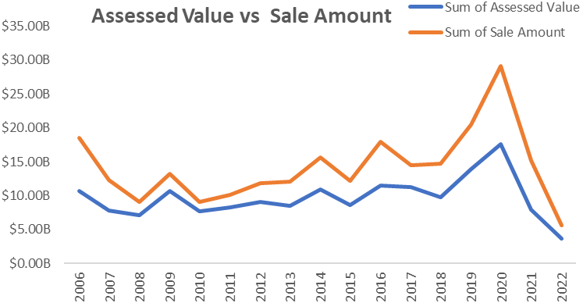
Figure 2
- “Assessed Value vs Sale Amount” line chart compares both trends side by side across years.

Objective 3: To rank cities based on total sales and identify the top five cities contributing the most revenue, helping in strategic decision-making for market focus and resource allocation.
  - General Description
This objective identifies which cities generate the most revenue from real estate sales, helping stakeholders prioritize investment or policy decisions.
  - Specific Requirements
- Group data by Town.
- Calculate total sales per city.
- Identify and rank top 5 cities.
  - Analysis Results
- Top 5 cities based on total sale amount:
  - Greenwich – $26.77B
  - Stamford – $11.74B
  - Fairfield – $9.14B
  - Darien – $8.52B
  - Westport – $8.31B
- Combined, these 5 cities contribute $64.48B, roughly 26.7% of total sales.
  - Visualization
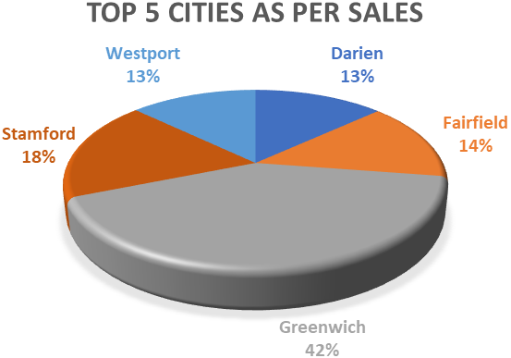
Figure 3
- Represented using a 3D pie chart titled “Top 5 Cities as per Sales” with percentage labels.

Objective 4: To calculate and analyze the total revenue generated for each property type, providing insights into which property categories contribute the most to overall sales.
  - General Description
This objective explores how different property categories contribute to the overall real estate market in terms of revenue generation.
  - Specific Requirements
- Group data by Property Type.
- Compute total sales per category.
- Identify the most and least contributing property types.
  - Analysis Results
- Single Family homes dominate sales with the highest contribution (over $160B, based on chart approximation).
- Condo and Residential properties are the next significant contributors.
- Three Family properties contribute the least.
  - Visualization
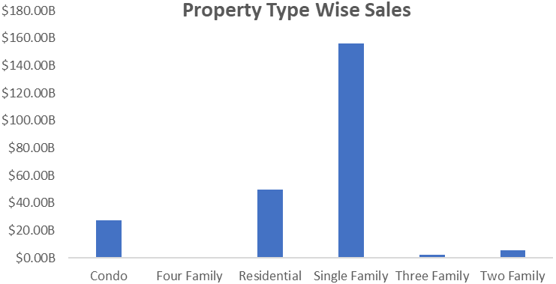
Figure 4
- Visualized using a bar chart titled “Property Type Wise Sales”, indicating revenue by each property type.

Objective 5: To analyze how accurately properties are assessed over time and across different property types, identifying patterns of over- or under-valuation that can help improve valuation models.
  - General Description
This objective evaluates how accurately properties are being assessed, which is crucial for tax calculations and investment planning.
  - Specific Requirements
- Compare Sales Ratio over the years.
- Identify if there are consistent over- or under-valuations.
- Analyze across different property types and time periods.
  - Analysis Results
- Sales Ratio Trends show fluctuations and indicate inconsistent valuation accuracy.
- Ratios are especially unstable in earlier years like 2006 and 2007.
- Post-2017 shows more stable but still slightly overvalued trends.
  - Visualization
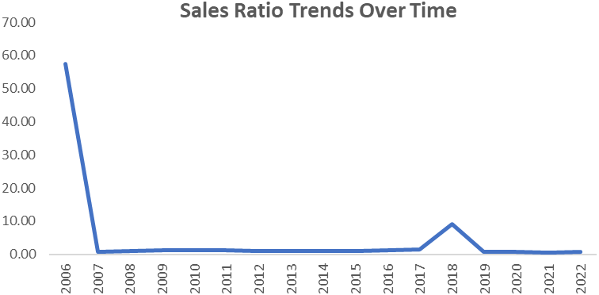
Figure 5
- Depicted in the “Sales Ratio Trends Over Time” line chart, reflecting changing valuation patterns annually.

Objective 6: Enable Dynamic Filtering with Slicers
  - General Description
Interactive slicers improve user control and personalization.
  - Specific Requirements
Add filters for Year, Offense, and Method.
  - Analysis Results
- Slicers empower users to extract custom insights.
- Useful for law enforcement, analysts, and policy makers.
  - Visualization
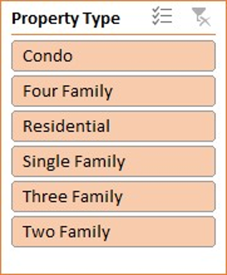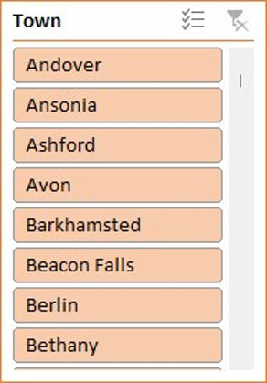
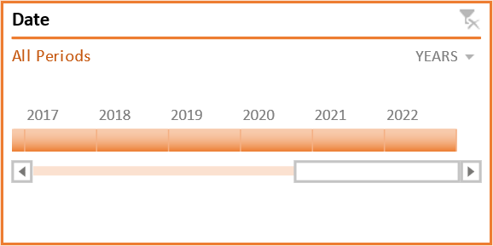
Figure 6
Slicers are implemented on the left panel of the dashboard.

- Conclusion
The dashboard and analysis provide a comprehensive overview of real estate sales patterns from 2006 to 2022:
- 2020 was a peak year for both sales amount and volume.
- Actual sale prices are consistently higher than assessed values, especially in major cities.
- Greenwich leads in revenue generation, followed by Stamford and Fairfield.
- Single Family homes remain the most valuable property type.
- The Sales Ratio helps gauge buyer behaviour and market pricing efficiency.

- Future Scope
The following enhancements could add more depth to the analysis:
- Incorporate recent data (post-2022) to evaluate recovery or decline.
- Predictive Modeling: Use ML to forecast future prices based on trends.
- Price per Square Foot: For more granular valuation insights.
- Time on Market: Analyze how quickly properties are selling.
- Geospatial Mapping: Use GIS to visualize town-wise and zip code-wise trends.
- Demographic Integration: Add buyer profiles (if available) for segmentation.

- References
[1] U.S. Government Open Data Platform, "Real Estate Sales 2001-2018," Data.gov, [Online]. Available: https://catalog.data.gov/dataset/real-estate-sales-2001-2018. [Accessed: Apr. 13, 2025].
[2] Microsoft Corporation, "Microsoft Excel," Microsoft Office, [Software]. Available: https://www.microsoft.com/en-us/microsoft-365/excel.

- Social Media Engagement
LinkedIn - https://www.linkedin.com/posts/adityaraj2112_dataanalysis-excel-powerpivot-activity-7311734341716295680-ZjrR?utm_source=share&utm_medium=member_desktop&rcm=ACoAAEbUag4BNe4-YDYTskf6jPmmoVy3Mh5TRSI
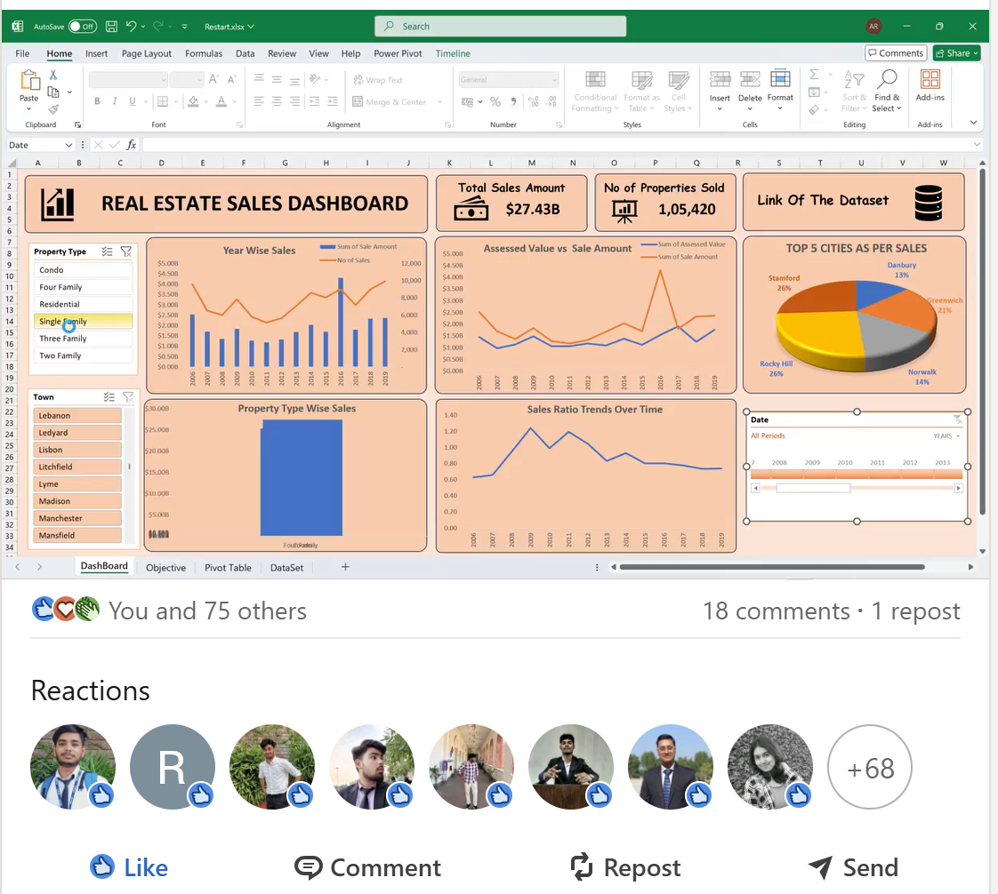
Figure 7

